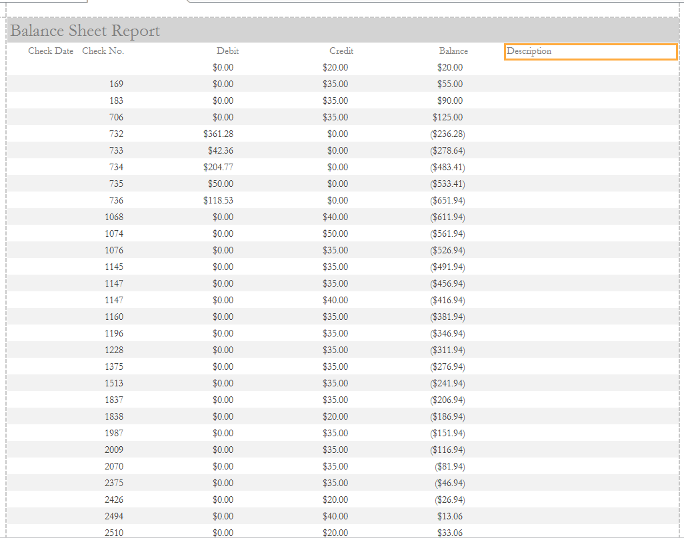

Report Name: Balance Sheet Report

Created by Donna Walker

Prepared for: Treasurer

Navigation Pane Location: ??

Query: Balance Report Query

Purpose: This report provides a running balance of all credits and debits entered for to the association’s account. Once it has dates entered, it could be queried by time period – month, year, periodic.